APPENDIX A: SPRINT CYCLE 1
- Summary data
Team number | 7
Sprint technical lead(s) | Ethan, Sarah
Sprint start date | 18/5/21
Sprint end date

- Individual key contributions
Team member | Key contribution(s)
Ethan | Programmer - game logic and mechanics
Sarah | Programmer - GUI
Umar | Sprint documentation
Sam | Management & Javadoc testing
Adam | Management & Javadoc testing
Will | Javadoc testing

- User stories / task cards

- The game should be fun to play and have a colourful and intuitive interface that reflects the spirit and character of the original board game.
- With the provision of the autonomous player agent feature, it should be possible for a full experience game to be enjoyed by just a single human player.

- Requirements analysis
F1 - The game shall be playable for a minimum of 2 players and a maximum for 6 players

F5 - There shall be the possibility for the players to play amongst an AI character - Non-player character. This AI shall be able to play as one of the characters as if played by a human player. The use of the AI does not circumvent the 6player maximum

F17 - The AI should have varying levels of difficulty for the human players to play against. These levels will determine how ‘well’ the AI shall play during the game. THe human players can choose their preferred difficulty before the game starts

NF1 - The software shall be written in python to ensure maximum portability across platforms

NF4 - The software design shall accommodate future updates or maintenance through well designed code

- Design
The following image shows the UML design for the AI, this will explain the class design for the program.
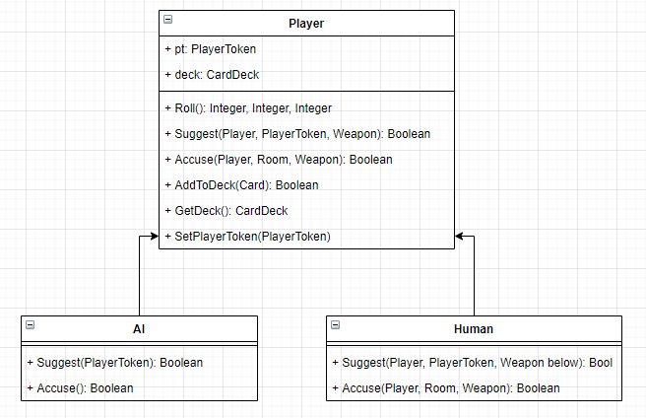
The AI class is designed to inherit from the player class, the same way that a human class would. This allows for an AI to use a majority of the same code as a regular player and therefore makes the program more efficient as less new code is required. AI and a human player will have the same functionality however an AI will make its decisions without the need of any input, compared to a human player that requires input.

The use case diagram will therefore be the same for the AI player as for the human player as they both inherit from the player class:
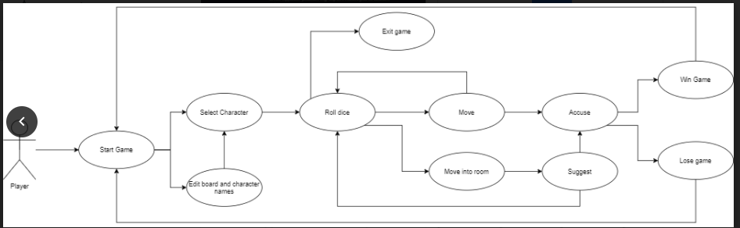
The sequence diagram will also remain the same for both types of players, however the AI will be given a character to play by the human players. 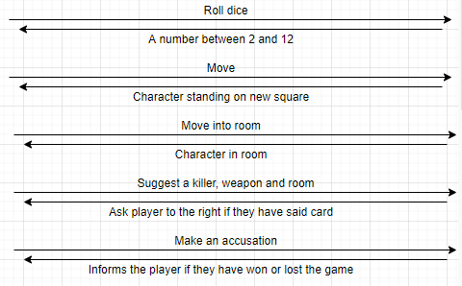

This sprint also includes any miscellaneous GUI work that requires finishing, whether it be changing the graphics for particular tiles, or adding more images. This allows for some reflection on the game so far and ensures that the GUI is.

The AI characters inherit from the player class, as do the human players. So considering the fact that the mechanics of the player and player movement have been thoroughly tested in previous sprints, thorough testing of the same mechanics via the AI isn’t as crucial. The AI will be executing the same code as the human player character; which has already been tested. Despite this, high level testing will still occur to ensure that the AI can execute the same mechanics as the human player; without the need for any user input.

- Test plan and evidence of testing

N/a, AI was unfortunately not implemented therefore has no tests

System Testing
ID | Req | Description | Inputs | Expected | Actual | Pass/Fail | Action
1 | F1 | Test that there can only be a maximum of 6 players including the AI | inputting 6 players on menu screen | There can be a maximum of 6 players including AI | AI has not been implemented in this sprint and therefore cannot be tested | Fail | Implement the AI functionality into the game
2 | F5 | Test that It is possible for a single player to play with an AI | Selecting AI on menu screen | It is possible for 2 players, one human and 1 AI | AI has not been implemented in this sprint and therefore cannot be tested | Fail | Implement the AI functionality into the game
3 | F5 | Test that all players can be AI’s | Choosing all players as AI | It is possible for all players to be AI’s | AI has not been implemented in this sprint and therefore cannot be tested | Fail | Implement the AI functionality into the game
4 | F5 | Test that the AI can roll the dice on its turn to receive a random number between 2-12 | play game with AI | The AI can roll the dice on its turn with no user input or provocation | AI has not been implemented in this sprint and therefore cannot be tested | Fail | Implement the AI functionality into the game
5 | F5 | Test that the AI can move on its turn to any tile within the range of its dice roll | play game with AI | The AI can automatically move to a desired tile after rolling the dice (within range) | AI has not been implemented in this sprint and therefore cannot be tested | Fail | Implement the AI functionality into the game
6 | F5 | Test that the AI can accuse a player of the murder | play game with AI | The AI can accuse a player of the murder | AI has not been implemented in this sprint and therefore cannot be tested | Fail | Implement the AI functionality into the game
7 | F5 | Test that the AI can suggest | play game with AI | The AI can suggest someone as the murderer | AI has not been implemented in this sprint and therefore cannot be tested | Fail | Implement the AI functionality into the game
8 | F5 | Test that the AI inputs a murder weapon when accusing | play game with AI | When accusing, the AI can input a murder weapon | AI has not been implemented in this sprint and therefore cannot be tested | Fail | Implement the AI functionality into the game
9 | F5 | Test that the AI inputs a murder room when accusing | play game with AI | When accusing, the AI can input a murder room | AI has not been implemented in this sprint and therefore cannot be tested | Fail | Implement the AI functionality into the game
10 | F5 | Test that the AI inputs a murderer when accusing | play game with AI | When accusing, the AI can input a murderer | AI has not been implemented in this sprint and therefore cannot be tested | Fail | Implement the AI functionality into the game
11 | F5 | Test that the AI character starts on one of the assigned starting squares | Start game with AI | On game start, the AI starts on a predefined tile | AI has not been implemented in this sprint and therefore cannot be tested | Fail | Implement the AI functionality into the game
12 | F5 | Test that the AI cannot walk through walls | Allow for AI to move | That the AI cannot walk through walls | AI has not been implemented in this sprint and therefore cannot be tested | Fail | Implement the AI functionality into the game
13 | F5 | Test that the AI can choose the remain stationary on its turn | run game with AI until they choose to remain stationary | That the AI can choose to remain stationary on its turn | AI has not been implemented in this sprint and therefore cannot be tested | Fail | Implement the AI functionality into the game
14 | F5 | Test that the AI can only enter rooms through the doors | Run game with AI until they enter a room | That the AI can only enter rooms through their doors | AI has not been implemented in this sprint and therefore cannot be tested | Fail | Implement the AI functionality into the game
15 | F5 | Test that once an AI enters a room, its move count ends | Run game with AI until they enter a room | That the AI stops moving once it has entered a room | AI has not been implemented in this sprint and therefore cannot be tested | Fail | Implement the AI functionality into the game
16 | F17 | Test that the AI has a varying level of difficulty that the user can choose | Select different difficulty for AI in menu screen | That the player can select a varying level of difficulty for the AI, on the menu screen | AI has not been implemented in this sprint and therefore cannot be tested | Fail | Implement the AI functionality into the game
17 | F5 | Test that any character can be played by the AI | Select all players for AI | That any particular character can be played by the AI | AI has not been implemented in this sprint and therefore cannot be tested | Fail | Implement the AI functionality into the game
18 | NF1 | Test that the code for the AI is written in python | visual inspection | That the code for the AI is written in python | n/a | Fail | Implement the AI functionality into the game
19 | NF4 | Test that the code is written so that it may accommodate future updates and maintenance | visual inspection | That the code accommodates future updates and maintenance | n/a | Fail | Implement the AI functionality into the game

- Summary of sprint

You should consider and discuss:

- Did you achieve your objectives for this sprint?
  - no, unfortunately due to time constraints and other factors, we were not able to implement the AI in this sprint and will most likely not be able to in the future. We therefore spent this time going through the existing program and working on it anyway we could, removing bugs etc.
- Is there a working prototype?
  - no, not for this sprint, theAI does not exist, however the rest of the game is still functional
- What went well, and what did not go well? If things didn't go well, what have you learned and what will you do differently for the next sprint?
  - When creating the cli, it was structured around the player giving input. As we were fastly running out of time, the implementation which was thought of could not be implemented without a full overhaul around the logic of the player classes and the cli
  - Due to the issues we faced as a team, we decided to take the time to fine tune the program rather than adding more functionality as this was not possible at the time. We worked more heavily on documentation and ensuring that all aspects of the current game worked

